CLOUD COMPUTING
ASSIGNMENT
S3-(Amazon Simple Storage Service) CREATION OF A PRIVATE BUCKET IN S3
STEP 1 –
We login into AWS as a root user and then search in the search box and look for S3 and go to the S3 which has a bucket as its logo. Later we see the S3 window and click on Create a bucket.
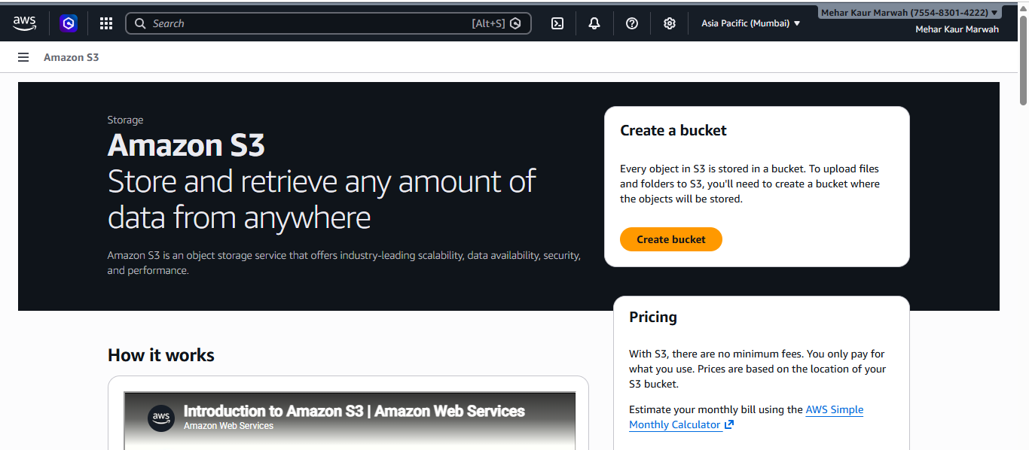

STEP -2
After we clicked on Create a bucket, we go to the next window where we must fill up all the details that are required to create a bucket.
First, we have General Configuration. In this we have Directory Bucket -(This is used for very fast access (low latency) and special cases. It stores data in only one availability zone,) and General Purpose Bucket ( normal S3 bucket used for most things like storing images, files, backups, websites, etc.) Here we choose General Purpose . Then we name our bucket , in this the name is mehar-13.
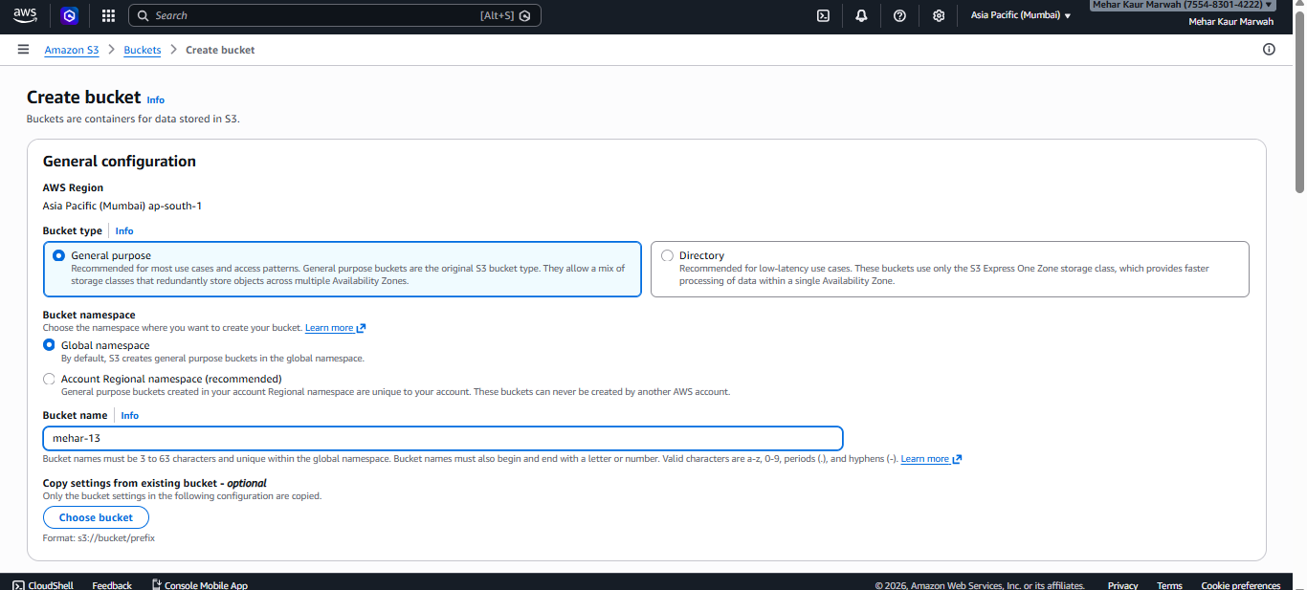

STEP – 3
Now we go to object ownerhip . Here we keep the ACLs disabled this means only people given access can see this bucket . 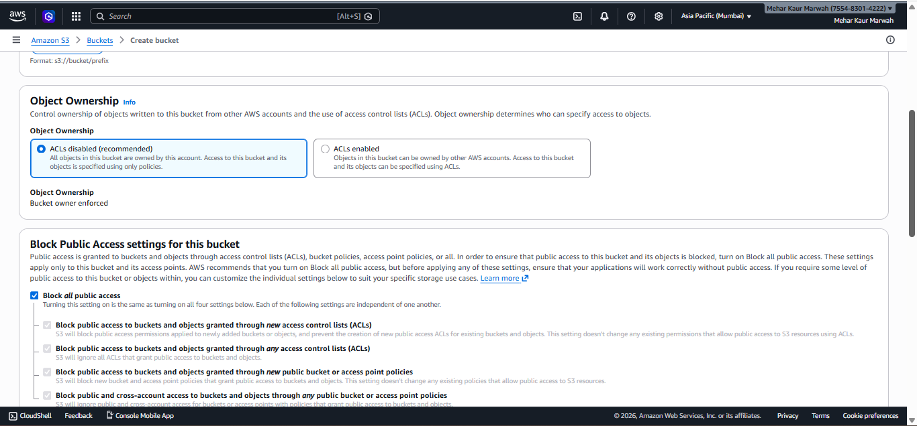

STEP- 4
Now we go to Access settings here we are choosing the option of blocking all public access as we are making a private bucket . 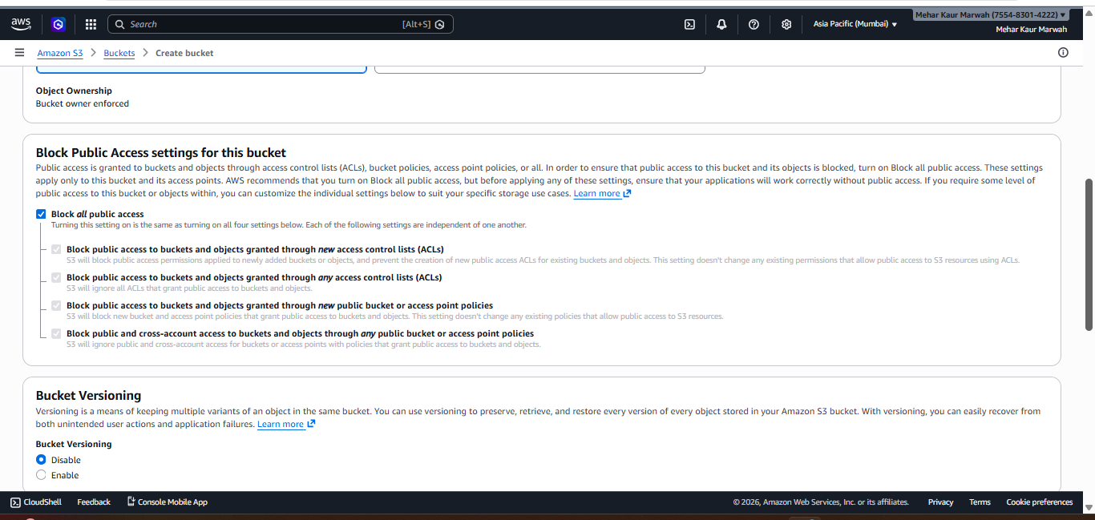
STEP – 5
BUCKET VERSIONING
Amazon S3 Bucket Versioning is a feature that allows you to keep multiple variants of an object in the same bucket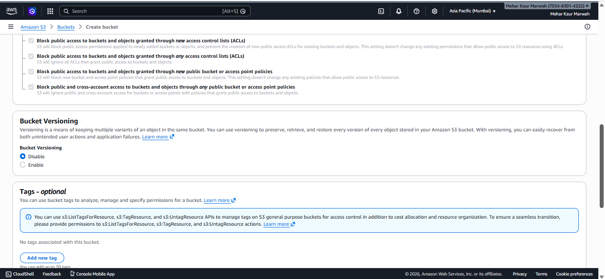
STEP-6
TAGS AND ENCRYPTION
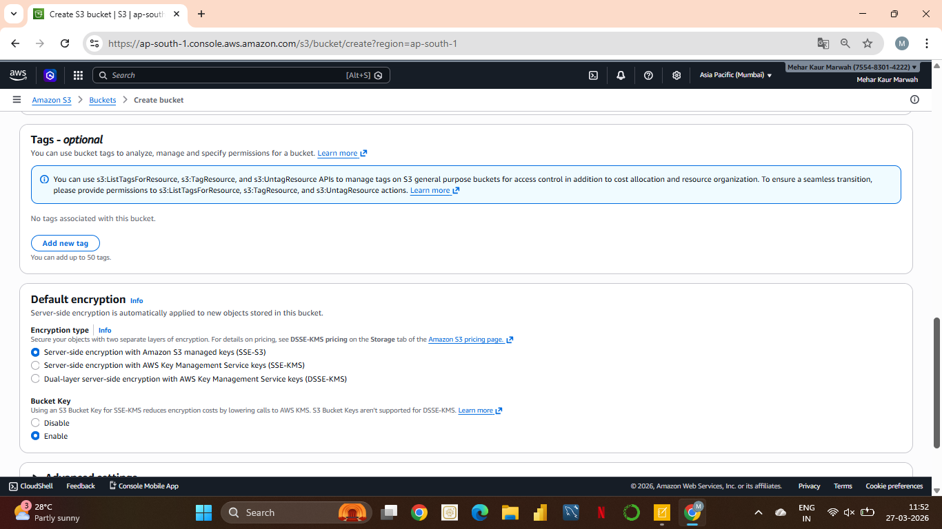
We keep the settings of tags and encryption as it is and after this we click o create bucket .
STEP-7
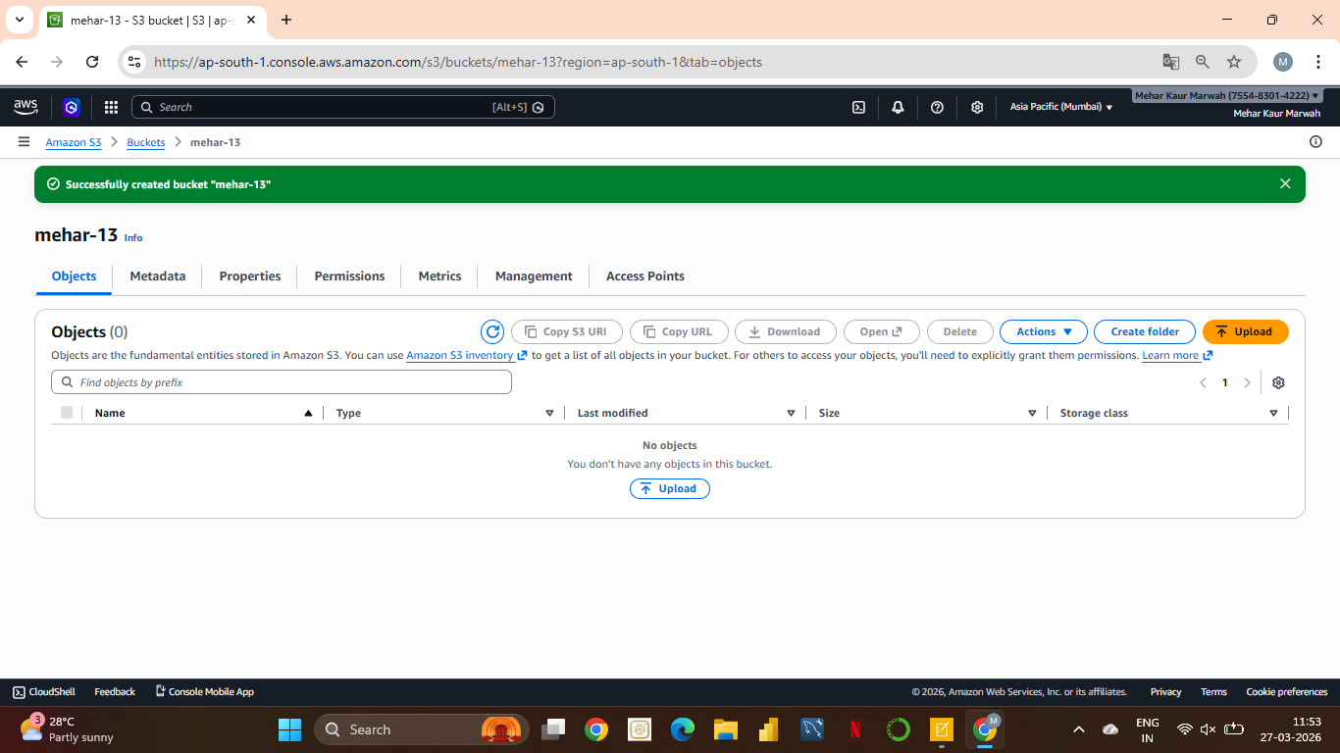
Our bucket has now officially been created and get an option to upload files
STEP-8

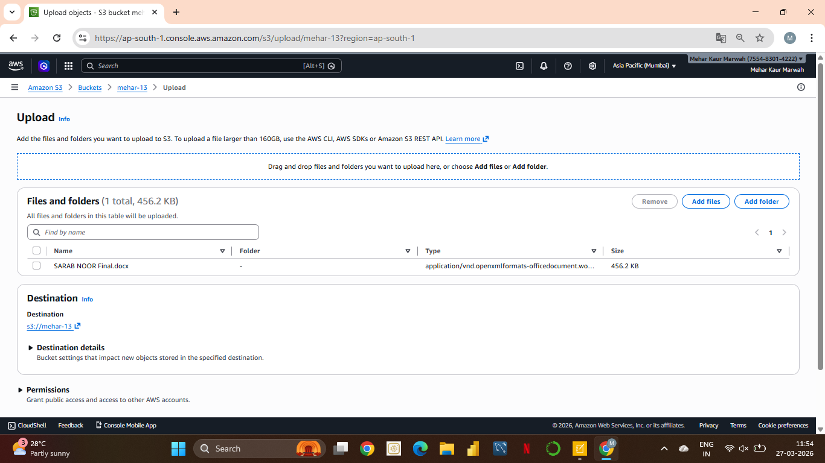

Now we upload our objects. Here I have uploaded a document called Sarab Noor.
STEP-9
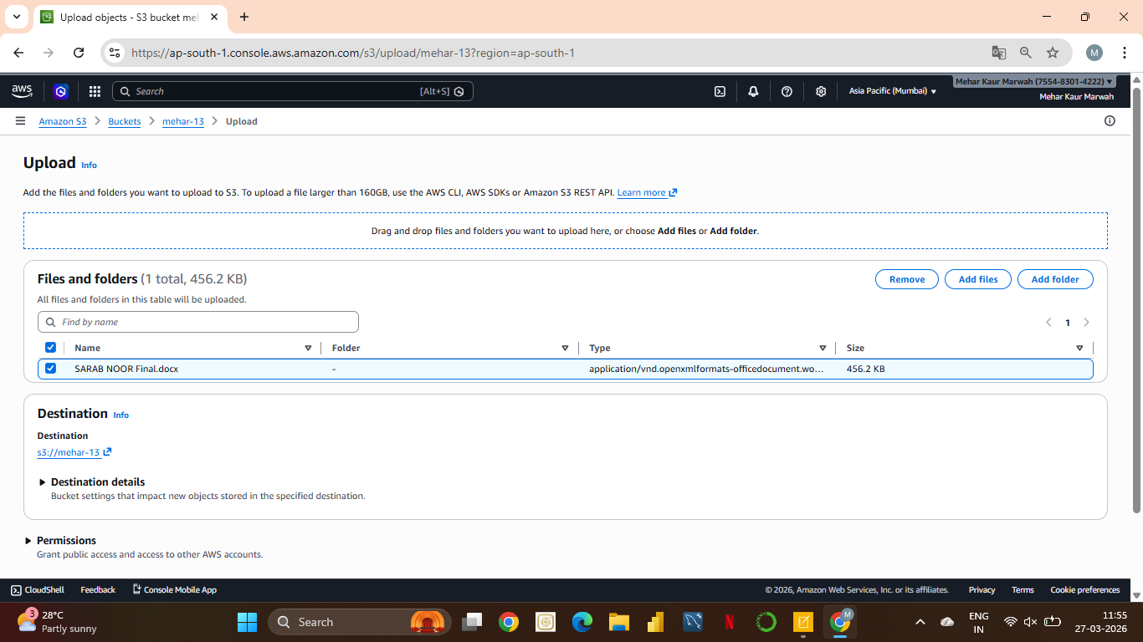
Now we select our file by clicking on the checkbox on left and click o upload a we scroll down.
STEP-10
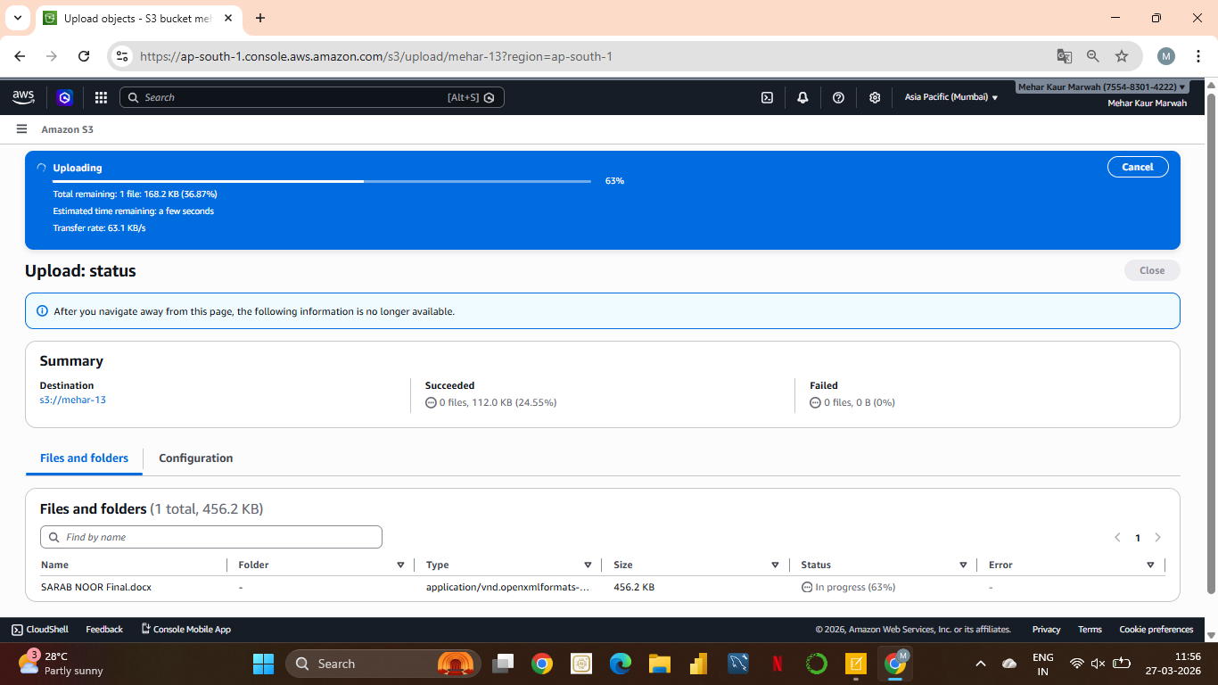
Here our file has been uploaded and our bucket has officially been created.

